Swimming With Sharks Report

USER alex ← Username sent in clear text

331 Please specify the password.

PASS L@wyer9 ← Password sent in clear text

230 Login successful. ← Authentication confirmed

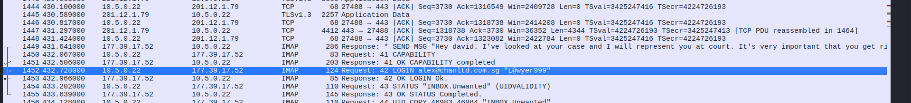

Email: alex@chanltd.com.sg

Possible Username: L@wyer999

\* SEND MSG "Hey david. I've looked at your case and I will represent you at court. It's very important that you get rid of the photos you showed me. The police may search your place at any moment. Keep in touch, Alex